Nikhara – Requirement Gathering and Analysis

Version 1.0

Prepared by Paramount Tech Labs
October 2011

SYNOPSIS
Nikhara Co-operative Banking Web Application provides, the Client (member of Nikhara group) to access their Co – operative bank accounts through online for banking purpose. The Client (member of Nikhara group) can view their transaction up to date at any point of time. The application also provides the facility to join people to Nikhara group through online. The Clients of Nikhara and people who want to join Nikhara group can access this application from anywhere at any time (24 X 7).
The project Nikhara Co-operative Banking Web Application has been divided into five modules. The Admin module is the module which is handled by the Admin. The Admin having administrative privileges will be controlling the website. The Client (member of Nikhara group ) can log in to the site can see their Account Balance, interest rate, transaction related information etc.
It has mainly five modules, they are
- Admin Module
- Client (member of Nikhara group ) Module
- Saving Bank Module
- Fixed Deposit Module
- Recurring Deposit Module

CONTENTS
TABLE OF CONTENTS | PAGE NO
CHAPTER – I INTRODUCTION | 4
- Nikhara Co-operative Banking Application - Overview | 4
- Objectives of the Project | 4
- Background Study | 5
- The Organization Profile | 5
- Study on Existing System | 5
CHAPTER – II SYSTEM ANALYSIS | 6
2.1 Study on Proposed System | 6
2.1.1 Defining the Problem | 7
2.1.2 Developing solution strategies | 7
2.2 System Specification | 9
2.2.1 Application Specification | 9
2.2.2 Network Specification | 9
2.2.3 Software Environment | 10
2.3 Cost Estimation and Scheduling | 10
2.4 Final Outline of the Proposed System | 11

1. INTRODUCTION

  - AN OVERVIEW

The project entitled Nikhara Co-operative Banking Web Application is aimed, to make the co-operative banking facility online. The Client can access the application to view their accont related information.

  - OBJECTIVES OF THE PROJECT

The main purpose of the project is to make the Co - operative Banking facility online.
  - It helps the Clients (members of Nikhara Group) then can view their banking related information from anywhere.
  - The can view all there transaction, they can search month wise , year wise, day wise .
  - Reports can be generated easily.
  - The transaction statement can be send to their Clients (members of Nikhara Group) monthly.
  - Consolidated report can be generated.

  - BACKGROUND STUDY
1.3.1 THE ORGANIZATION PROFILE
Nikhara Souharda Credit Co-Op Ltd has its roots since 1997. It is managed by Ex-Officials of public Sector Banks / undertakings and other MNC Organizations.
Mr. Kodanda Ram P, a Certified Banker (CAIIB) having Business Management Degree(BBM) and Law background(LLB) with an experience of over 20 years at various levels in State Bank of India, is spearheading the activities of Nikhara Group.
He is widely recognized as Authentic & Merited Insurance Advisor by LIC of India, the No.1 Brand of Corporate India. He is a member of Million Dollar Round Table (MDRT) USA, an organization of topnotch financial and Insurance Advisors of world based on Performance.
1.3.2 STUDY ON EXISTING SYSTEM
The Existing software for the Co – operative banking is a windows application. If the Client (member of Nikhara Group) what to do a transaction like deposit, withdrawal or want to know the transaction details of the deposit / withdrawal , they have to come to bank for getting it to be done.
DEMERITS:
- Lengthy turnaround for Clients (member of Nikhara Group) service.
- Client visit necessary for account opening/transactions.
- New Client acquisition difficult since there is no online facility
- There is no instant notification to Client for their transactions.
- For viewing the transaction/ deposit/ withdrawal, Clients (member of Nikhara Group) have to either visit Nikhara Co –operative Bank or Nikhara Co – operative bank need resource to deliver the service. Thus increasing operational cost.

2. SYSTEM ANALYSIS

2.1 STUDY OF PROPOSED SYSTEM
The Nikhara Co-operative Banking Web Application is developing for improvement of the Co – operate banking facility. In the faster growing world it is necessary to have an online application for bank to reduce the time and to perform the efficient work. It helps to maintain the transaction like deposit / withdrawal & information about the transaction details by faster and efficient in processing of information and more timely information are produced. Nikhara Co-operative Banking Web Application which will provide the Client (member of Nikhara Group) can view their bank account balance, trasaction during a time period, interest got in year informations so easily and quickly.
The benefits of the proposed system are
- Better turnaround for servicing the Client (member of Nikhara Group) for doing a transaction or getting the details of transactions.
- New Client acquisition easy for co – operative banking
- Clients can see their account related information like Current balance, transaction details etc. at any time (24 X 7)
- Reduce Manual work, thus reducing errors.
- Faster and efficient in processing of information.
- More timely information can be produced.
- Automatic report generation.

Database Data Security/ Protection

Database mirroring: If any changes is happening on database that will reflect on the other database which is used as backup. So if one system get crashed we can you the other system.

2.1.1 DEFINING THE PROBLEM
The existing system is a windows application. From the Nikhara Co – operative Web application you will get the information for creating member, SB (Saving Bank) accounts, FD (Fixed Deposit) accounts and RD (Recurring Deposit) accounts and that must to be added in the Windows application databases (MsSql Server 2008 R2);
    - The data which we will send from our web application has to synchronize with the windows application database (MsSql Server 2008 R2) and vice versa.
    - How do you do this synchronization?
    - In what format the windows application will generate data for updating the information in Nikhara Co – operative web application?
2.1.2 DEVELOPING THE SOLUTION STRATEGIES
Nikhara Co – operative Web application incorporates the following aspects
- Admin Module
- Client (member of Nikhara Group) Module
- Saving Accounts Module
- Fixed Deposit Module
- Recurring Deposit Module

Admin Module
Admin have to approve all requests like sign up as a member, creating sb accounts, creating fd accounts and creating recurring accounts from the external user(who want to be a meber of Nikhara Group). Once approved, these informations will be send to windows application to update in core application database (MsSql Server 2008 R2). Any request which comes from Client through netbanking module, i.e. transaction of SB A/c or FD A/c or RD A/c has to be approved by the Admin. Admin can view all Clients(member of Nikhara Group) details, transaction details etc.
Client (member of Nikhara Group) Module
Client (member of Nikhara Group) can create SB Accounts, FD accounts and RD. Client Can create initiate deposits for SB A/c or FD A/c or RD A/c. They can view their account related details like account balance, interest rate and transaction related informations. Client will get the report of transaction through email on monthly basis via the medium they have subscribed.
Saving Accounts Module
This module is mainly aimed to provide Saving Accounts features to Client(member of NikharaGroup). Creating Saving Bank Accounts, putting requests deposit or withdrawal etc.
    - Showing Account balance(Current Balance) of Savings Account
    - Saving Account Transaction report
Fixed Deposit Module
This module is mainly aimed to provide Fixed Deposit features to Client(member of NikharaGroup). Creating Fixed Deposits, deposit or withdrawal of money under deposits etc.
    - Showing Account balance(Current Balance) of Fixed Deposit
    - Fixed Deposit Transaction report
Recurring Deposit Module
This module is mainly aimed to provide Recurring Deposit features to Client(member of NikharaGroup).
    - Creating Recurring Deposit
    - Depositing moneyon monthly basis in RD account.
    - Showing Account balance(Current Balance) of Recurring Deposit
    - Recurring Deposit Transaction report
2.2 System Specification
2.2.1 Application Specification

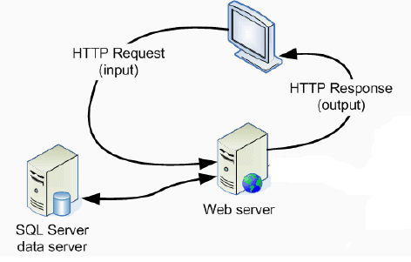

2.2.2 Network Specification
2.2.3 Software Environment
- Operating System: Red Hat Linux
- Technology: Lamp
- Front-End: PHP, HTML
- Back-End: MySql
- Web Server: Apache
- Web Browser: Any
The pages are being designed using html and the code logic is developed using php. The backend used is mysql.
2.3 Cost Estimation and Scheduling
Since cost plays quite an important role in deciding the new system, it must be identified and estimated properly. Costs vary by type and consist of various distinct elements. Benefits are also of different type and can be grouped on the basis of advantages they provide to the management. The benefits of a project include:

1) Cost-savings benefits

2) Cost-avoidance benefits
3) Improved-service-level benefits
4) Improved-information benefits
Cost-saving benefits lead to reduction in administrative and operational costs. Cost-avoidance benefits are those which eliminate future administrative and operational costs. Improved-service-level benefits are those where the performance of a system is improved by a new computer-based method. An improved-information benefit is where computer based methods lead to better information for decision making. The costs associated with the system are expenses, outlays or losses arising from developing and using a system. But the benefits are the advantages received from installing and using this system.
Cost Benefits as follows
- Reduce of paper work
- Reduce man power
- Can reduce advertisement for getting more customers.
2.4 Final Outline of the Proposed System
The final outcome of the project web based co – operative banking solution for Nikhara group, which is capable of performing all functions related to co – operative banking easily.
- The User can access the system from anywhere any time (24 X 7) they can view the report as well.
- Better services to existing Clients: Co – operative can provide online banking facility to all Clients (members of Nikhara).
- New customer acquisitions

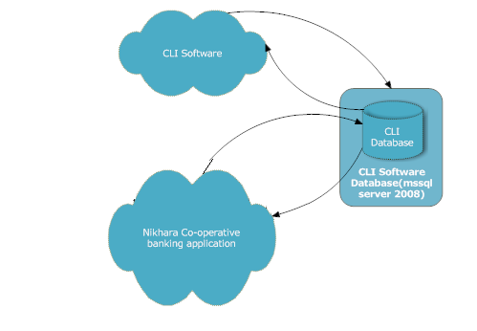
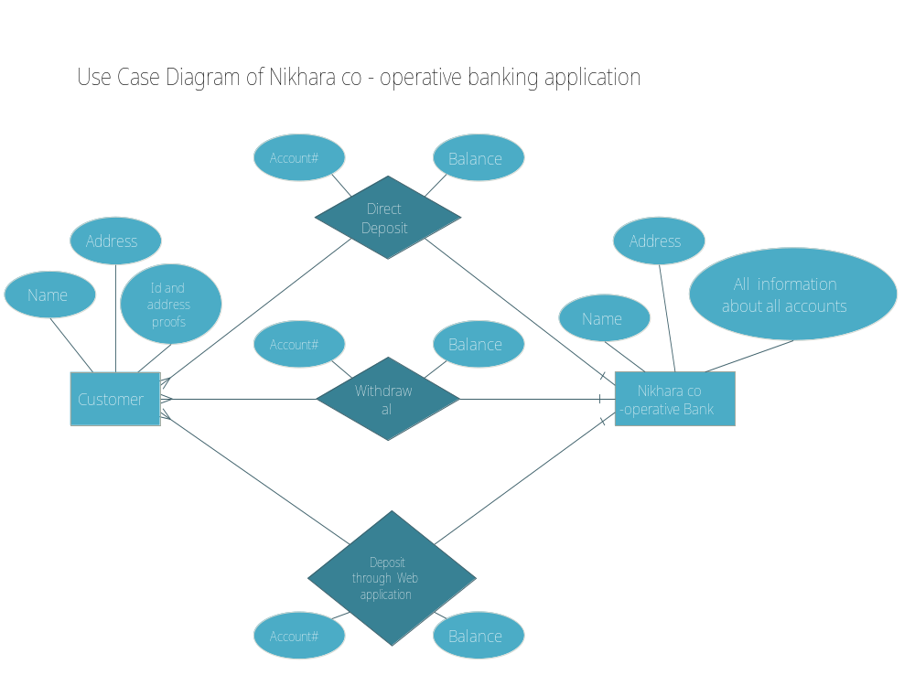

NIKHARA CO-OPERATIVE BANKING SOLUTION

USAGE:
The Nikhara admin / Officer can create member ship, creation of all accounts like savings bank, fixed deposit and recurring deposit through web application. The same way Clients can also create their member ship, creation of accounts and transaction through online.

TRANSACTIONS:
Bank Transactions, Account creation and member ship creation can be done by using 2 systems ie, through web application and Existing CIL Software.

Member ship Creation / Updation:

There are 3 ways for creating member ship for Nikhara co-operative bank.

- Member ship Creation/Updation request can be done by the user directly through online:

Creation:
User can access the web application and they can request for member ship through sign up. Once they enter the necessary information for member ship (Necessary information required fields will display in the form) then they have to submit it. Once they submit the information the request will goes to admin. The request will go through email to both admin and the requester.

Client has to fill the following details for creating member ship
- Personal Information
- Proof details
- Nominee details
- Payment method

The admin / the privileged officers have to approve the member ship request after doing the verification of the information. Once the approval is done by the concerned person the member ship will be created in the MSSQL SERVER 2008 R2 Database.
Updation:

If member wants to change any profile (can change only limited fields) information after admin approval, can do it online directly. If member is changing any profile details then again admin approval is required.
.

- Direct Member ship Creation / Updation done by admin(through Web application):

Creation:

Admin can create member ship behalf of Client through online. If some Clients or user is coming to Nikhara co-operative office and requesting for creating a member ship, at that time admin can create the member ship for Client. If the admin is creating the member ship there is no need for approval because the admin will verify all the documents before creating the account. Once they submit, the member ship id will be get created in MSSQL SERVER R2 Database.

Updation:

After approval of the member ship one email will go to the member email id. This email will be sent for verification of the member (It would contains the username and password). Client has to verify the email id by clicking the link which has been send by the web application.

- As per the privilege, Sales Officer can also create / update the member ship:

Creation:
If the admin is assigning the privilege for creating member ship to Sales Officer then officer also can create member ship through online. Who are all coming to Nikhara office for requisition of member ship, either officer or admin has to create it.

Updation:

After approval of the member ship one email will go to the member email id. This email will be sent for verification of the member (It would contains the username and password). Client has to verify the email id by clicking the link which has been send by the web application.

Dataflow between (Web Application and MSSQL SERVER R2 2008) for member ship creation / Updation:
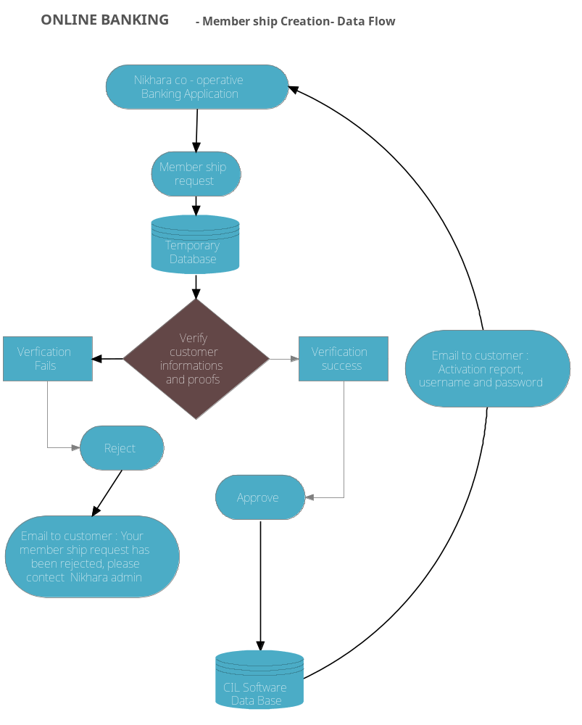

Bank Account Creation (Savings Bank Account, Fixed Deposit, Recurring Deposit)

Creation of accounts can be done different ways.

- Member can create bank account through online:

After creation and activation of member ship, the member (Client) can create bank accounts like saving bank, fixed deposit and recurring deposit.

One member can create multiple accounts like savings bank, fixed deposit and recurring deposit.
After account creation request has been send by the member, then admin / privileged officer will verify the account. The admin / privileged Officer is having the facility to approve or reject. Based on the action performed by the admin / privileged officer the process will go.

If approved then these accounts will be created in MSSQL SERVER R2 2008. Notification email goes to concerned person. If is approved also the notification email will go to the requester.

After creation of Savings bank account, then only member can create FD account. If RD Is greater than 5k then that member should have an SB account.

- Admin / Privileged officer Can create account behalf of member:

If the member is directly coming to Nikhara co-operative office for creating account, then admin / privileged officer can create accounts for member directly through online. All of these details will be updated in MSSQL SERVER 2008. Email notification will goes to member email id.

Dataflow between (Web Application and MSSQL SERVER 2008 R2) for different bank account creation / Updation:
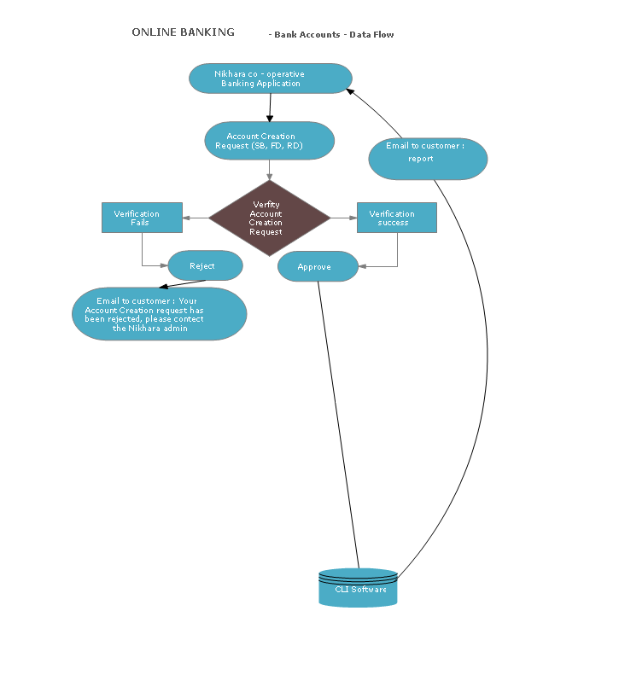

Transaction for (Savings Bank Account, Fixed Deposit, Recurring Deposit)

Transaction for all accounts also done in different ways.

- Member can put transaction request through online :

After putting the amount in bank the member will get reference number. With the help of reference number the member can create a request for transaction. The admin / privileged officer will verify the transaction with the help of bank transfer reference number. After verification they will approve/ reject it. Notification will go based on approval / reject to member email.

Transaction can be down in 3 ways
Directly putting money to Nikhara bank account (Axis, yes bank etc.)
Internal transfer ( eg: SB to RD)

Uploading the cheque and putting the deposit details (Which bank they have deposited the cheque, on which date etc.) about cheque.

- Direct contact with Nikhara co-operative bank:

All members (Account Holders in Nikhara co-operative bank) can do transaction directly through Nikhara co-operative bank also.

The admin / privileged officer can create transaction either through web application or through CIL Software.

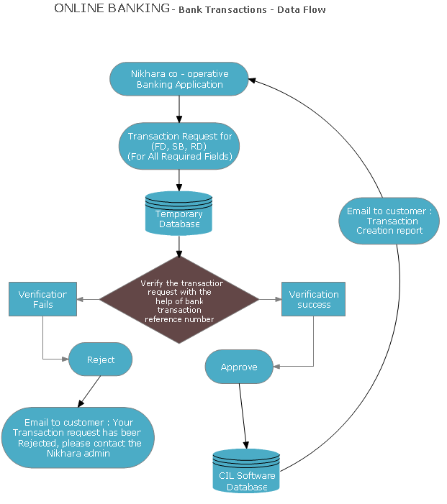

Client Management

Roles

Nikhara Admin: The person as Nikhara admin has the full power of the system. The Admin can do the following functionalities

- Create member ship
- Create Accounts (Savings Bank, Fixed deposit, Recurring Deposit)
- Approve / Reject the transaction
- Assigning functions to Sales Officers (Creating member ship, create accounts, approve/ reject transactions etc.)

Sales Officers:
Based the privilege assigned by the administrator, officers can do the functionality like creating member ship, creating accounts and approve / reject transactions.

Time Estimation
50 working days ( 1 resource)
ADMIN MODULE : Total 20 days
Please see the admin module tasks as follows
Admin can Create/ Edit/ Approve/ Block -> Member ship
Admin can Create/ Edit / Approve /Block -> Bank Accounts (Savings Bank, Recurring Deposit, Fixed Deposit)
Admin Can Create / Edit / Approve/Remove -> Transaction for all Accounts
Reset all clients password based on the requirement from the Account holder
Admin can view all Account holders accounts, transacations
Admin can view the logged in time of all accounts holders to there accounts
Print, Pdf Facility
Email Functionality For each action which happend on banking application
Screen management
Role management
Change password behalf of user.

Client MODULE : Total 14 days
Please see the user module tasks as follows
Client → Request for member ship creation
Account Holders can request for creating All bank accounts (SB, RD, FD).
Account Holdrs can request for new transactions
Account hloders can track previous transactions
Account holder can send request to change password
Account holders can send request to change their profiles
Print , Pdf Functionality
Email Functionality For each action which happend on banking application ( Their Accounts)
Project Planning & Database Design : Total 5days
Designing : Total 3 days
Testing : Total 8 days
For 1 Resource it will take 50 days to finish, as we are two we can finish it in25 days.

The project has started on 7th – May -2012 From there it would take 25 days. The project completion date is 08-June – 2012.

